# New business location recommendation system

*The location used for this project is Toronto city, and the business is a fast food chain*

## *By Mjidiba*

## Introduction

Hi everyone. In this project we will tackle one of the problems mentioned in the instructions for the assignment, which is a recommendation system of where to open a new business.

If someone is looking to open a business in the city of Toronto, how can we recommend the best neighborhood to open his business in? The idea is that we want to open a business in a neighborhood where that venue type is least common to maximize profits and avoid competition.

For this problem, we will take as an example an investor who wants to open a fast food chain in the city of Toronto. We will give at the end our recommendation of where to open the restaurant, and where not to open it.

## Data description

The data used for this project will be obtained from Foursquare (<https://foursquare.com/>) and from a Wikipedia page containing the list of postal codes for Canada (<https://en.wikipedia.org/wiki/List_of_postal_codes_of_Canada:_M>). The Information about the neighborhoods as well as popular venues within them will be obtained using Foursquare API.

## Methodology

First of all, we will extract the information from the Wikipedia page, which is a table containing 3 columns: Postcode, Borough and Neighborhood. We will be using for this the ‘BeautifulSoup’ library. Then we will perform some modifications so as to have one line for each postal code, meaning that we will group neighborhoods of the same postal code, and fill the empty ones with their corresponding Borough

Next, we will search for coordinates for each postal code in Toronto and add them as two separate columns to the table. We will be using for this an already prepared csv file that contains each postal code with the corresponding coordinates.

This what looks our data like when plotting it in the notebook using the folium library

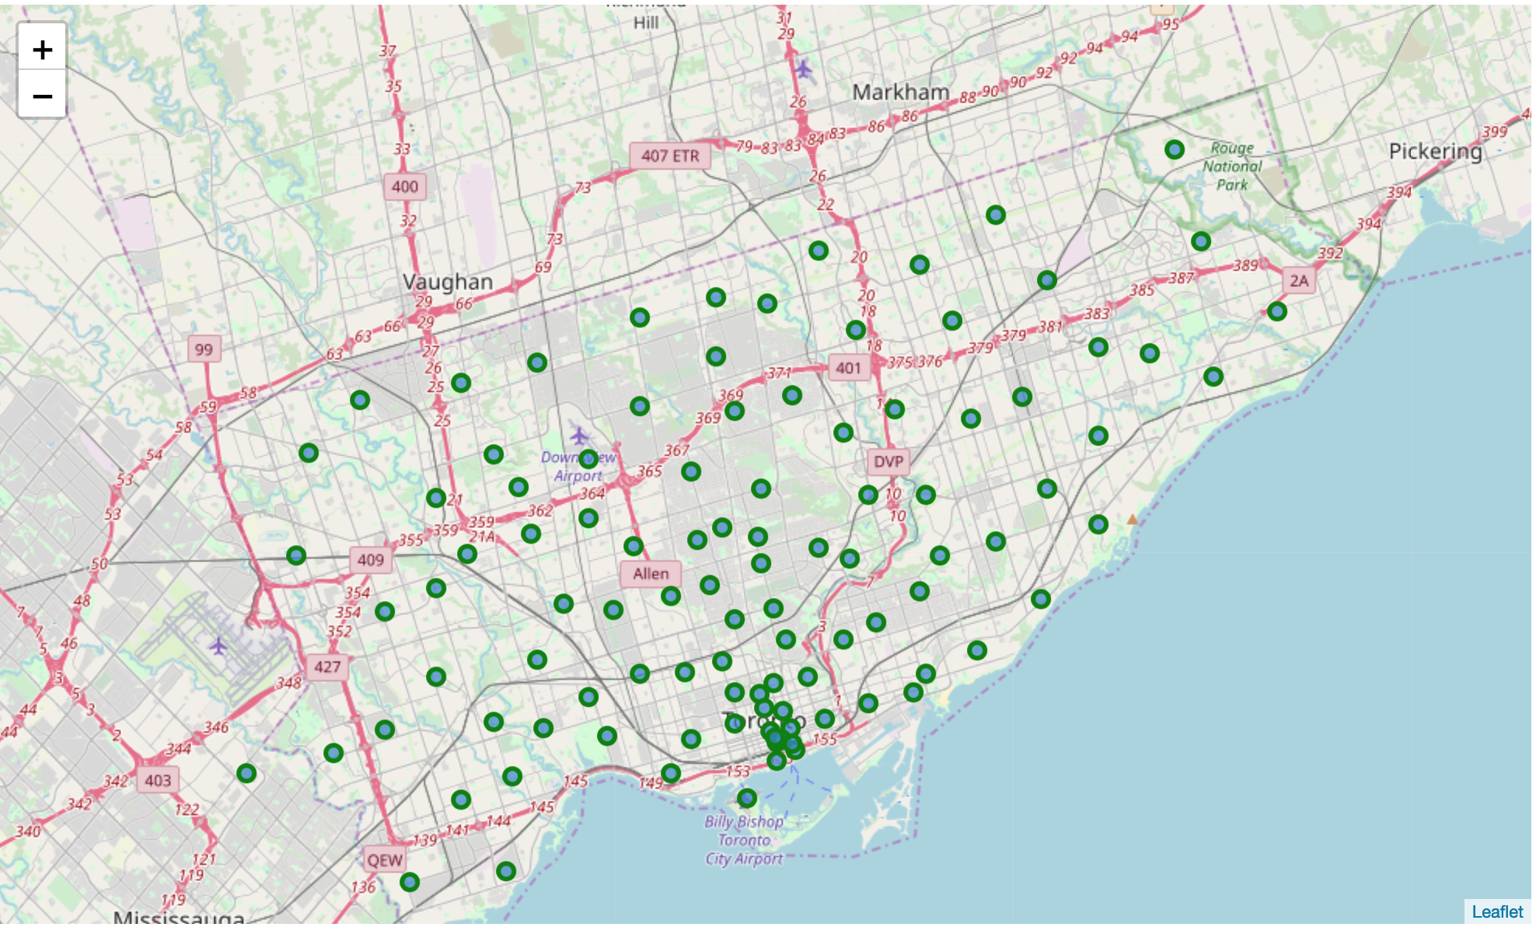

Then, using Foursquare API, we will create a dataset containing all the venues in a radius of 1km to each borough. We suppose that 1km is the maximum distance that people are willing to walk to a certain business (in our case, a fast food restaurant).

Finally, we will calculate a value for each line (borough) that describes the degree of presence of fast food chains in that area. This will be a sum of the fast food chains present in that area, multiplied by the distance from the borough center. So, we don’t only consider the number of restaurants that are present in the area, but also if they are concentrated in the center or in the sides

## Results & discussion

First of all, using the Foursquare API, we were able to extract the venues within 1km of each set of neighborhoods with a certain postal code. Then, we only left the venues with ‘Fast Food Restaurant’ as category. The resulting dataframe is the following table:



There is a little problem that we are facing. When we just created the dataframe, we had 2240 venues, but when we only left fast food restaurants, we only had 38 venues. This means that we have now at most 38 neighborhoods in our dataset.

So, instead of looking for the neighborhoods for the least competition, we will be looking for the neighborhoods with the most intense competition to avoid. We will be looking for the neighborhoods with the highest number of fast food chains present in it. The result is:



So, I would recommend to this investor to avoid the neighborhoods Fairview, Henry Farm, Oriole, L'Amoreaux West and Steeles West, because they contain a total of 8 fast food chains.

## Conclusion

I think that the methodology that we used in this project is rather simple and still lacks a lot of things. First of all, we should not only examine the fast food chains, but also the restaurants that are present in the area. Another thing that we could have done is see which type of fast food our investor will be selling, and give more value to the restaurants that have the same business. For example, if the investor is selling burgers, we would put more emphasis on fast food restaurants like ‘Burger king’ and ‘McDonald's’. One last thing we could have is to examine the population within each neighborhood, higher population meaning higher profits.

This methodology can also be applied to other businesses like starting up a hotel or a supermarket, we just need to change the filtered category we used in the notebook. This methodology however is not applied to smaller cities, where there are less venues in each neighborhood. If we have an average less than one similar venue in each neighborhood like in our case, it will not be reflective of the true reality.